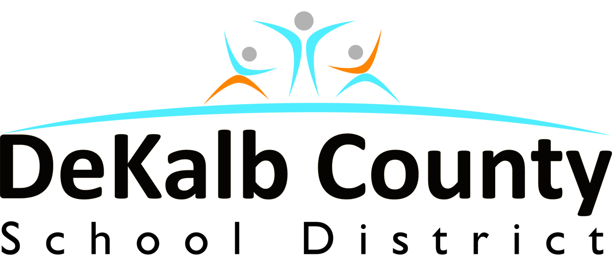
Dr. Malik Douglas
Principal

Interim Superintendent
Dr. R. Stephen Green
Superintendent

Interim Superintendent
Flat Rock Elementary
4603 Evans Mill Road
Lithonia, Ga. 30038
678-875-3202 office
678-875-3210 fax

October 16, 2017

Dear Parents:

The month of October has arrived and the Red Ribbon Committee is hard at work preparing activities for our observance of Red Ribbon Week. This year Red Ribbon Week will take place October 23-27, 2017. The theme for this event is “Your Future Is KEY, so stay Drug-Free.” There will be activities planned for the entire week and the culminating activity will take place on Friday, October 27, 2017 with a Red Ribbon Pep Rally in the gymnasium. The Red Ribbon Committee is very excited about this year’s activities and we have included a list below.
“Your Future is KEY, so stay Drug-Free”
Activities All Week
Red Ribbon Pledge Daily
Drug Education (K-5) Health Classes
Red Ribbon Facts (K-2) and (3-5)

Monday, October 23, 2017 – “Hats off to being DRUG –FREE.”
- Students, faculty and staff will wear their favorite hat.

Tuesday, October 24, 2017 – “It’s Cool to BE DRUG – FREE.”
- Students, faculty and staff will wear their favorite pair of shades.

Wednesday, October 25, 2017 – “TWIN UP Against DRUGS”
- Students, faculty and staff will dress alike with their friend, classmate, etc. to show that together we are drug free.

Thursday, October 26, 2017 – “RED – Y to live DRUG –FREE.”
- Students, faculty and staff will wear red to show that we are pledging to live a drug free life.
- Red Ribbon Parade featuring the Arabia Mountain HS Marching band around the community.

Friday, October 27, 2017 – “Our School is Drug-Free”
- Students, faculty and staff will wear red and black as our special guest will appreciate these colors.

The Red Ribbon Committee would like to thank each of you in advance for your support of all planned activities and we are looking forward to all parents joining our parade by wearing red shirts in support of drug awareness.

Sincerely,
The Red Ribbon Committee

Building An Inspiring Community of Learners
www.dekalb.ga.k12.ga.us

Building and Inspiring a Community of Learners
www.dekalb.k12.ga.us

